**Resume of**

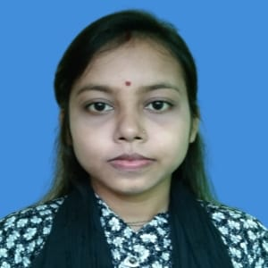 **Ripa Rani**

Mailing Address:

Cell:01318131419

Email: [soc191504747brur@gmail.com](mailto:soc191504747brur@gmail.com)

Address: Sonsbor,Post:Kanuya-5610,Rajarhat,Kurigram

**Career Objectives:**

Willing to build up career in challenging that will provide future opportunities for growth take a change utilize my skill that acquired from my education and experience.

**Educational Qualification:**

**1.Bachelor of Social science**

Institution : Begum Rokeya University, Rangpur

Subject : Sociology

Passing Year : 2023

Result : 3.11 (out of 4)

**2.Higher Secondary Certificate**

Institution : Mir Ismail Hossain College, Rajarhat

Group : Humanities

Passing Year : 2019

Result : 4.00 (out of 5)

**3.Secondary School Certificate**

Institution : Rajarhat Govt. Girl’s High School

Group : Science

Passing Year : 2017

Result : 3.95 (out of 5)

**Skills**

* Teamwork
* Communication
* Time Management

**Personal Information**

|  |  |
| --- | --- |
| Name  Father’s Name  Mother’s Name  Nationality  NID  Blood Group  Marital Status  Religion  Height  Permanent Address  **References** | : Ripa Rani  : Kanak Chandra Barman  : Jhuti Rani  : Bangladeshi  : 5113369440  : O+  : Married  : Hinduism  : 5”  : Sonabor,Post:Kanuya,Rajarhat,Kurigram |

Name : Ramprosad Barman

Designation : Assistant Professor

Institution :Begum Rokeya University,Rangpur

Phone Number :01736202610

Email : rpbarman@brur.ac.bd

**Declaration**

I declare that information provided in this form are correct, true and complete to the best of my knowledge and behalf.

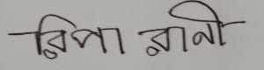

Ripa Rani